1. **Create user with name Techie and provide sudo access to user.**

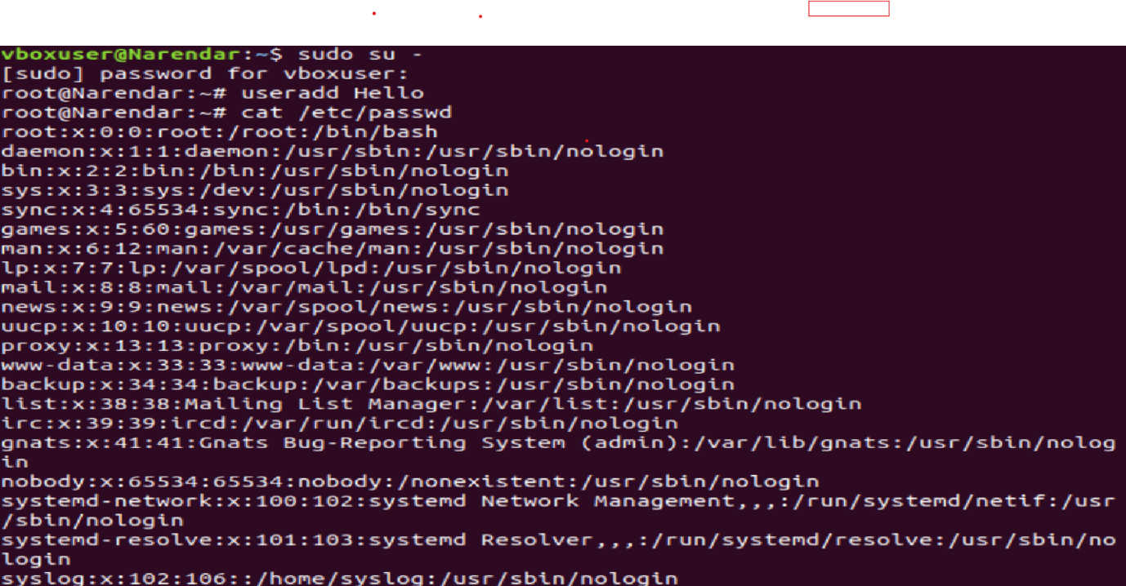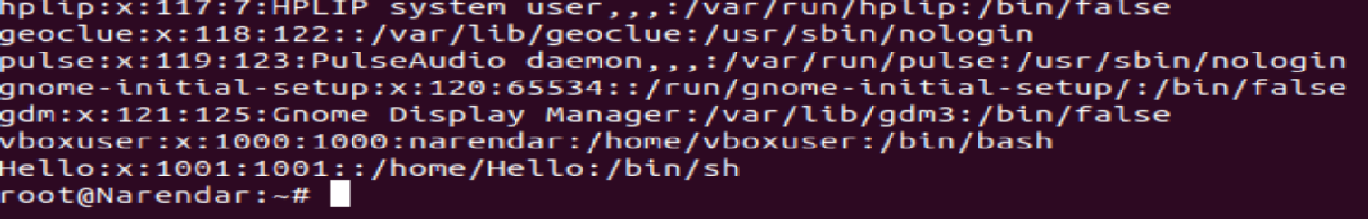

1. **Navigate to the home directory.**



**3) Create a new directory.** 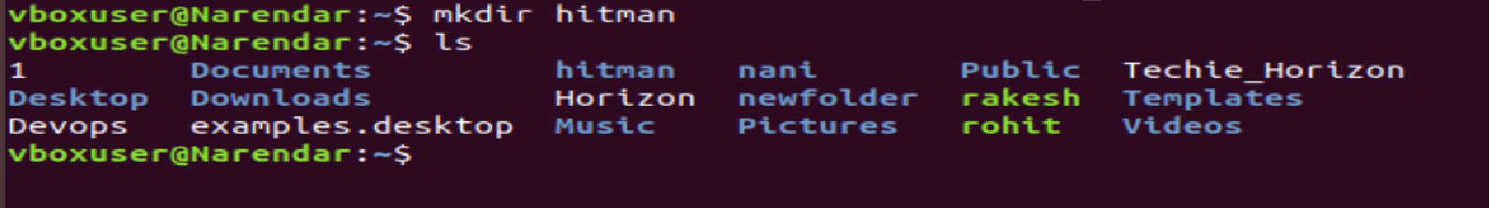

**4) List the contents of a directory.** 

**5) Change the current directory.** 

**6) Create a new empty file.**

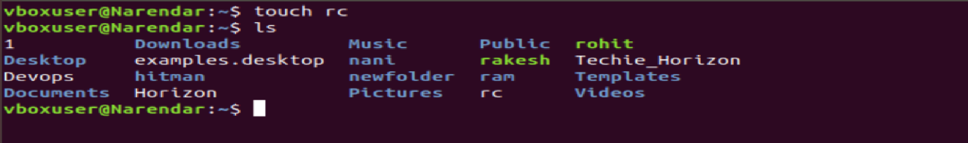

**7) View the contents of a file** 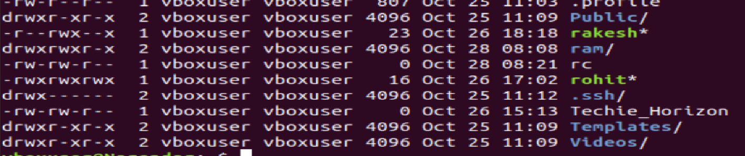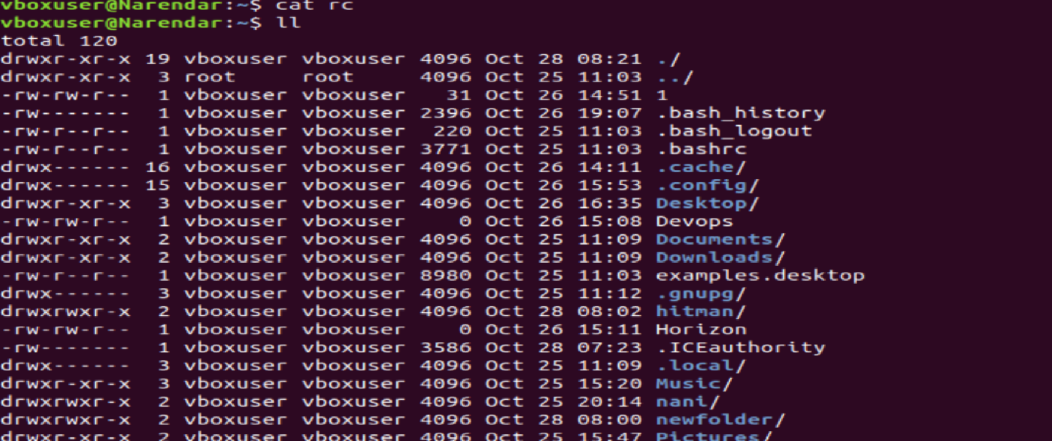

**. 8) Copy a file to another location.** 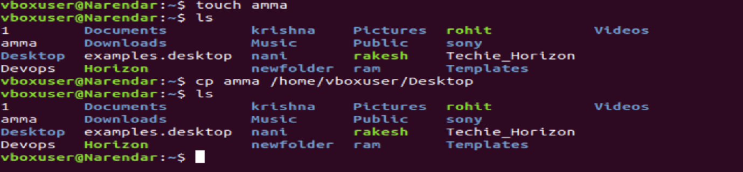

**9) Move a file to another location.** 

**10) Rename a file.** 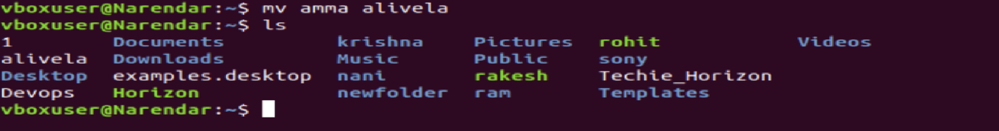

**11) Delete a file.** 

**12) Grant or revoke permissions on a file or directory.** 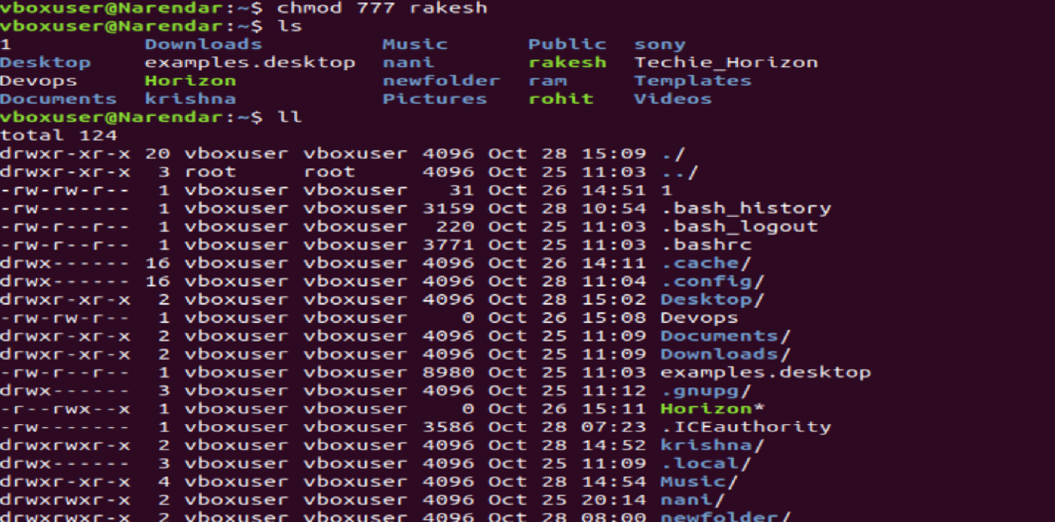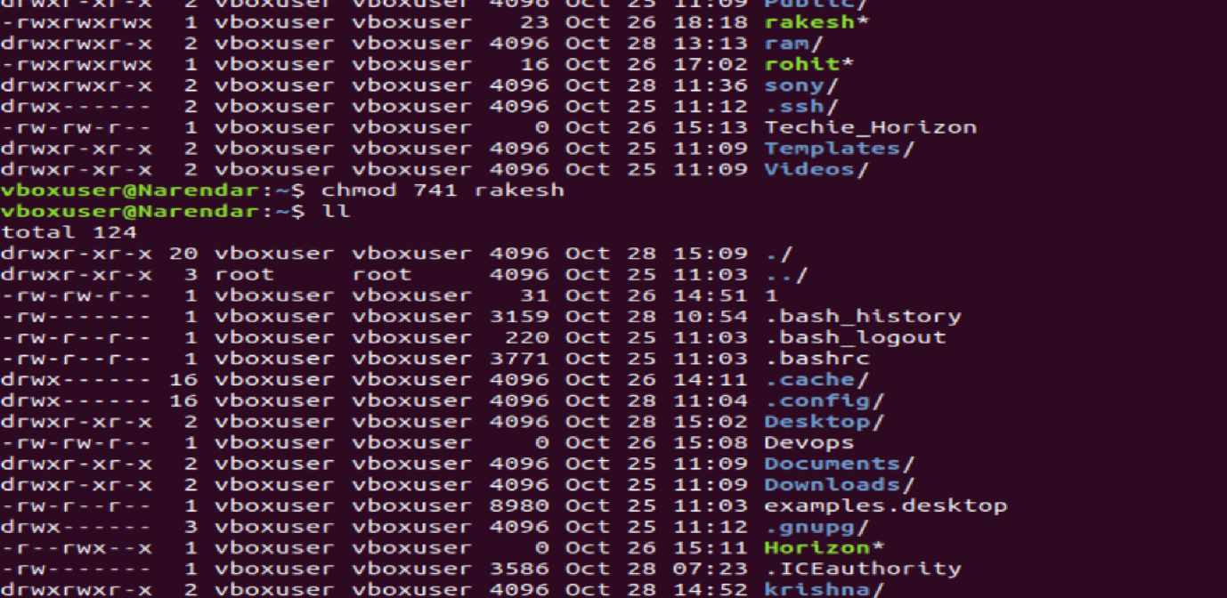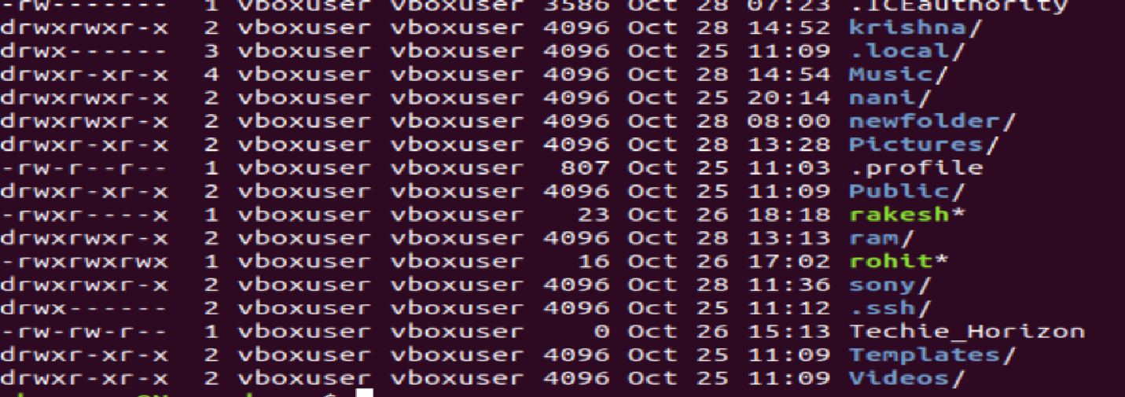

**13) View the current date and time** 

**14) Check the system uptime** 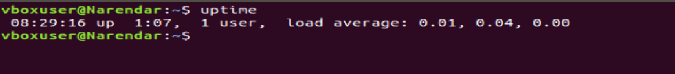

**15) View the running processes** 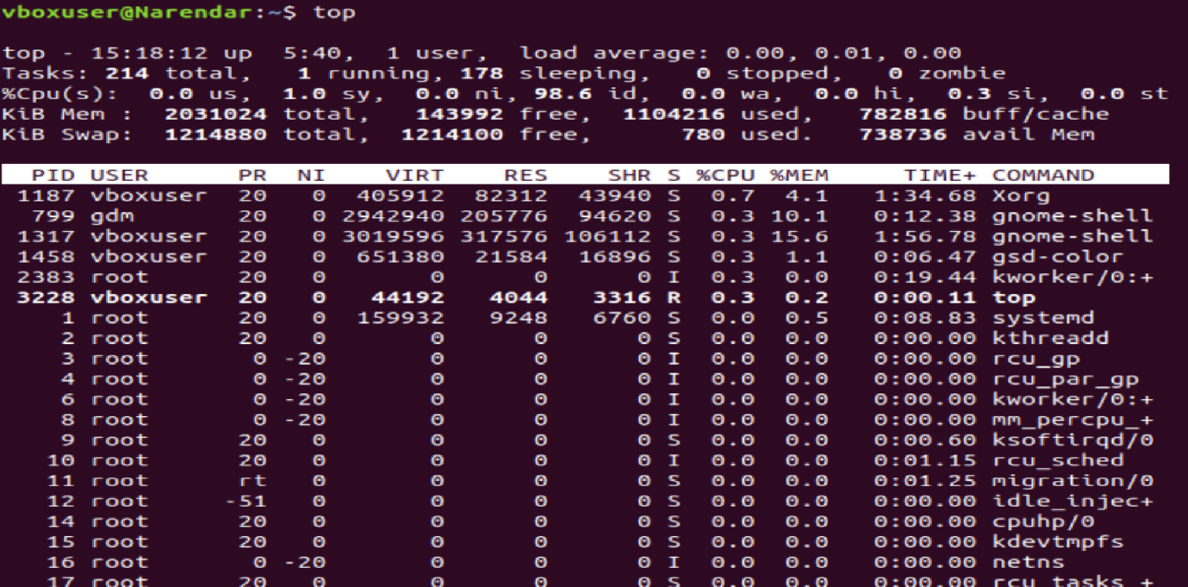

**16) Kill a running process** 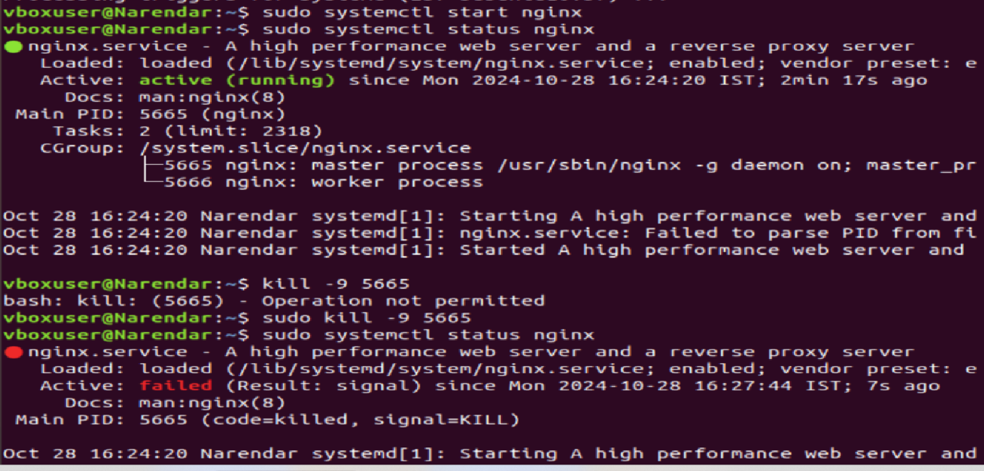

**17) Install a package using the package manager (e.g., apt or yum)** 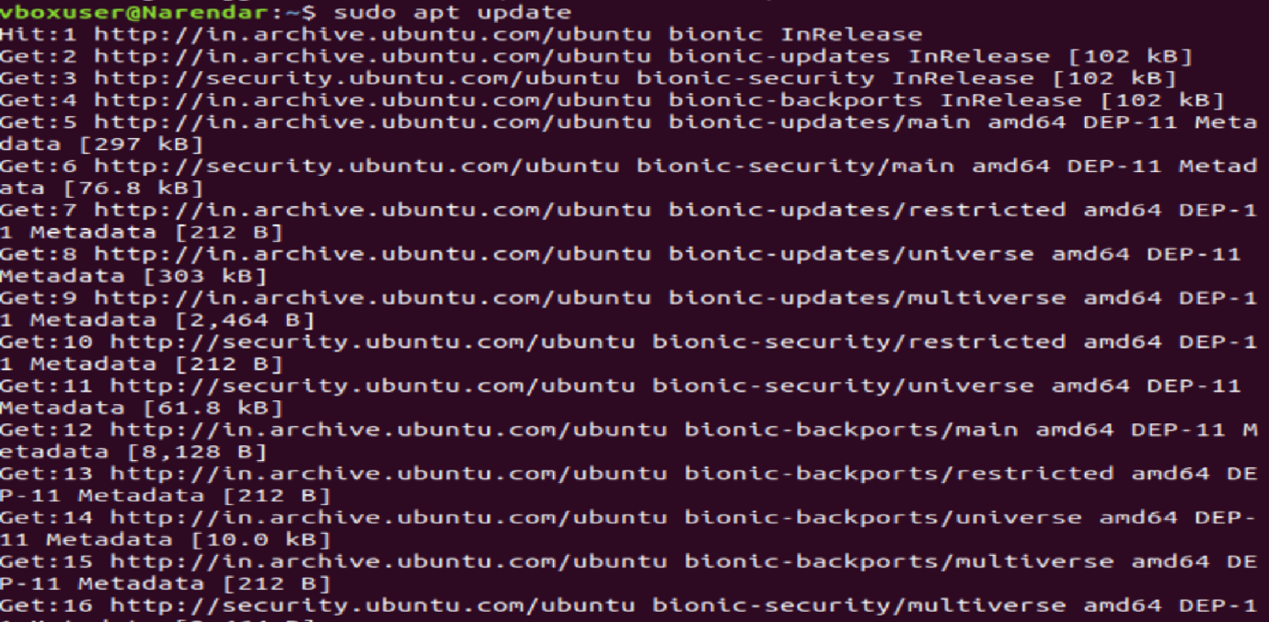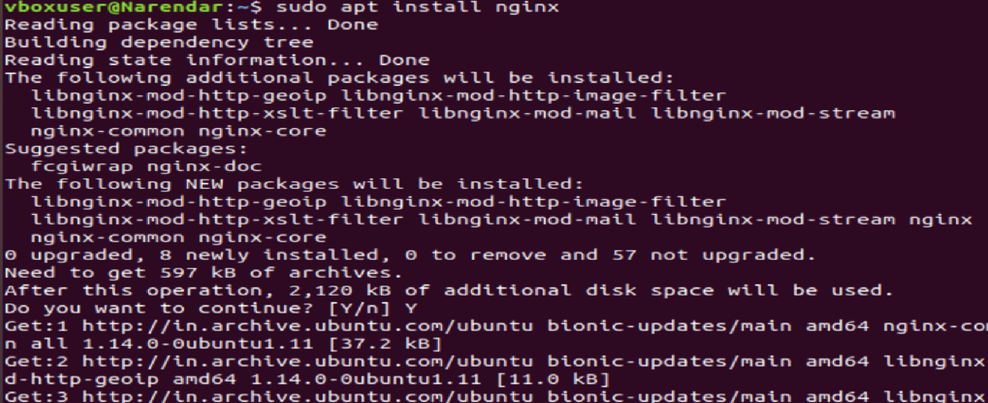

**18) Update the system packages** 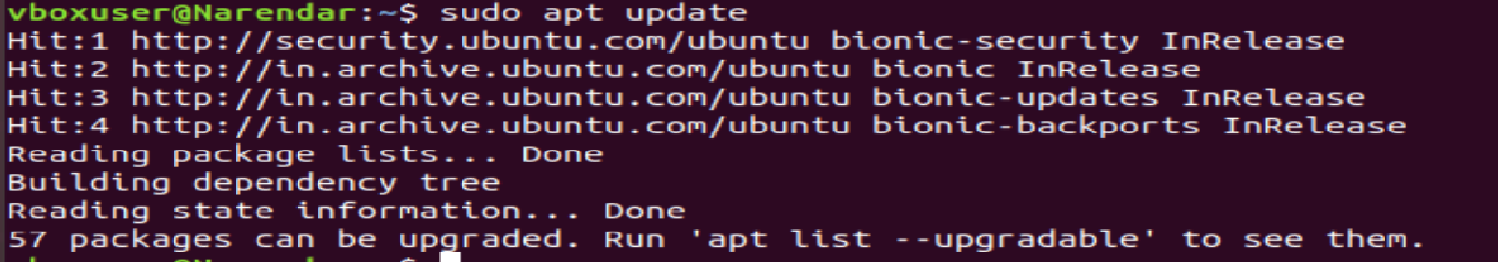

**19) Create a symbolic link** 

**20) Search for files using the find command.** 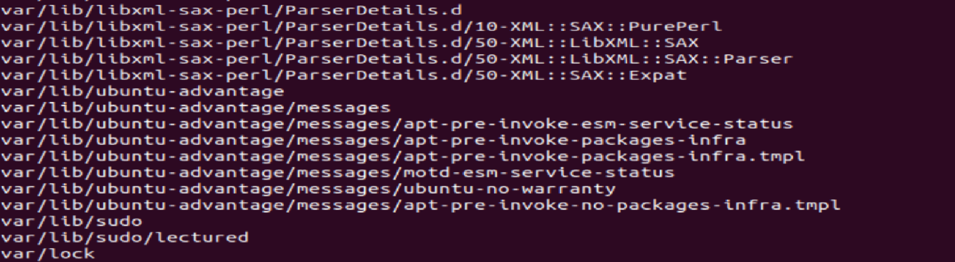

**21) Compress and decompress files using tar** 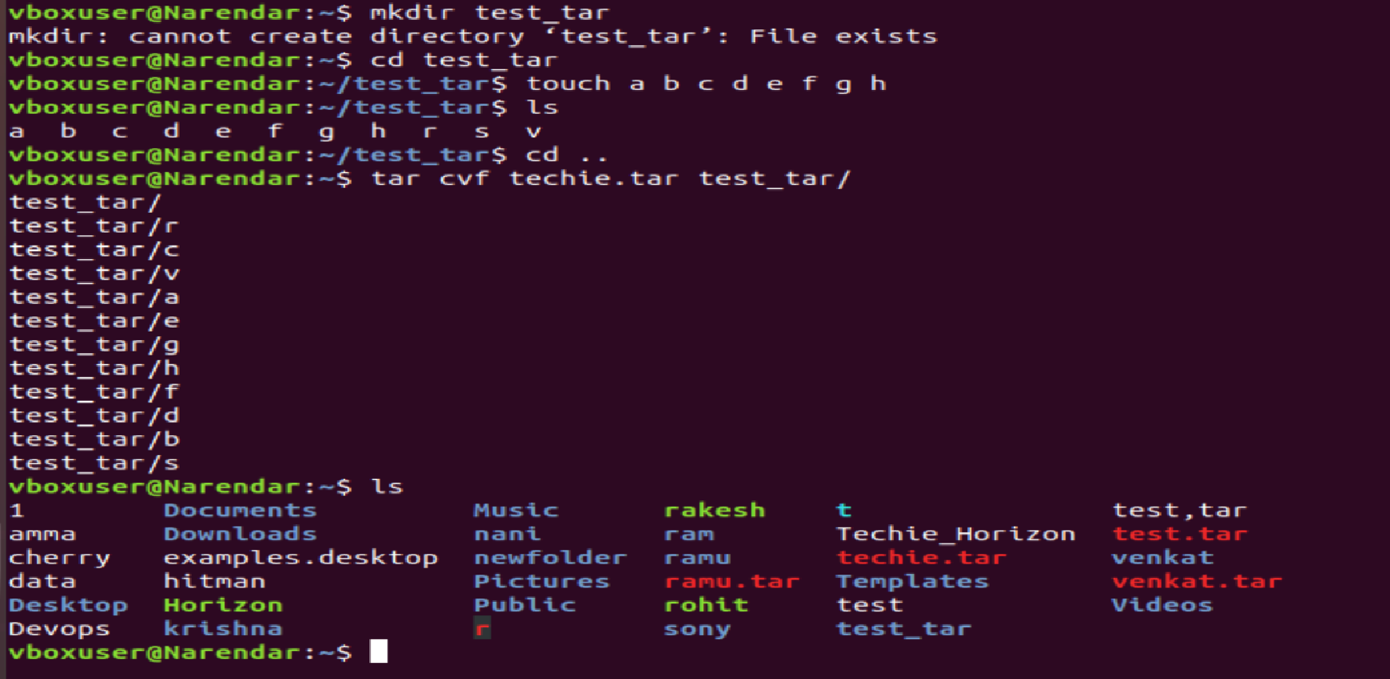

**22) Monitor system resources with top or htop.** 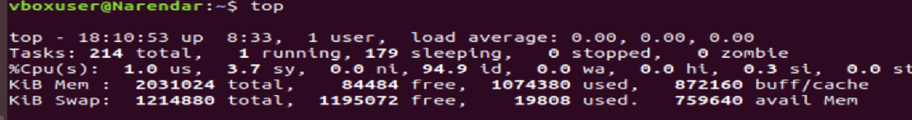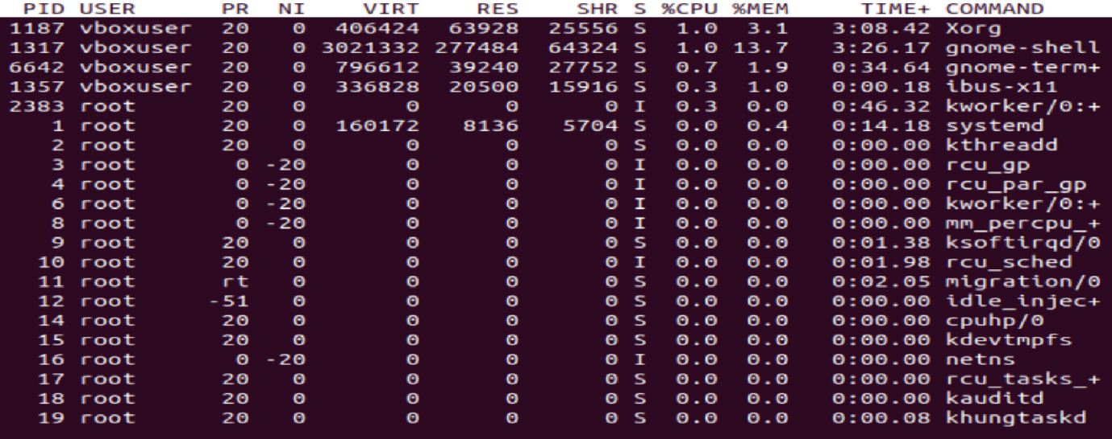

**23) Create and manage user groups** 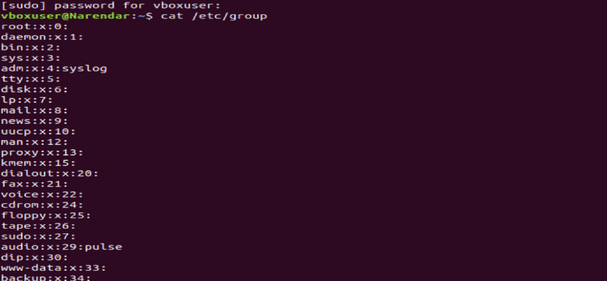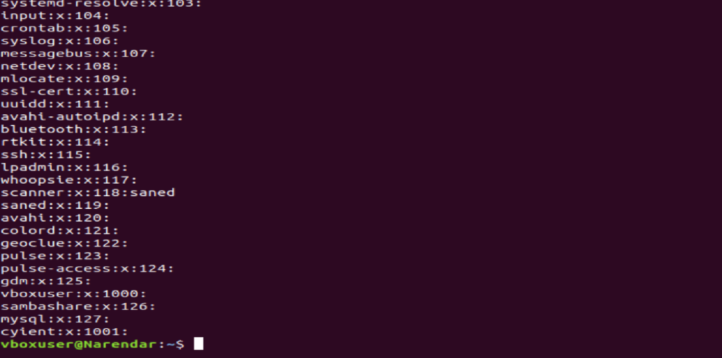

**24) Set up SSH password less authentication** 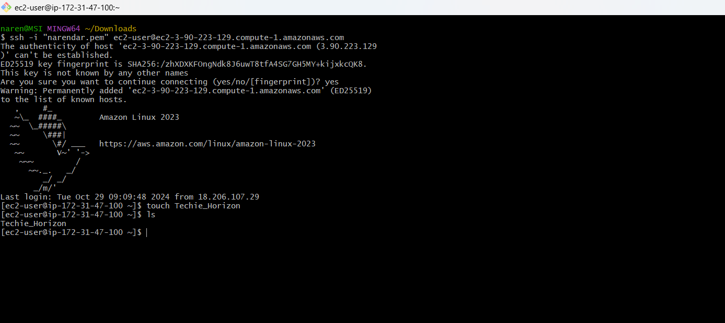

**25) Monitor log files using tail or grep.**



**26) Set up a web server (e.g., Apache or Nginx).** 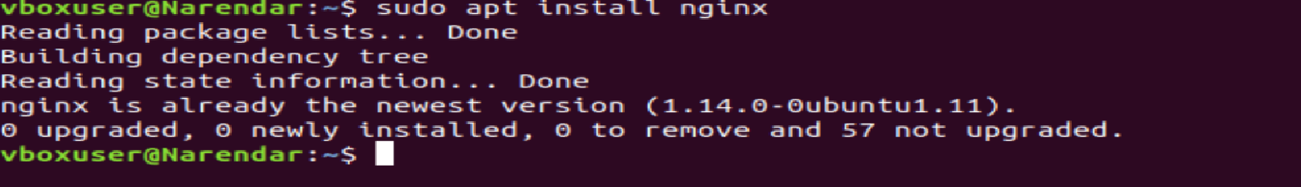

**27) Configure and secure a MySQL Database.** 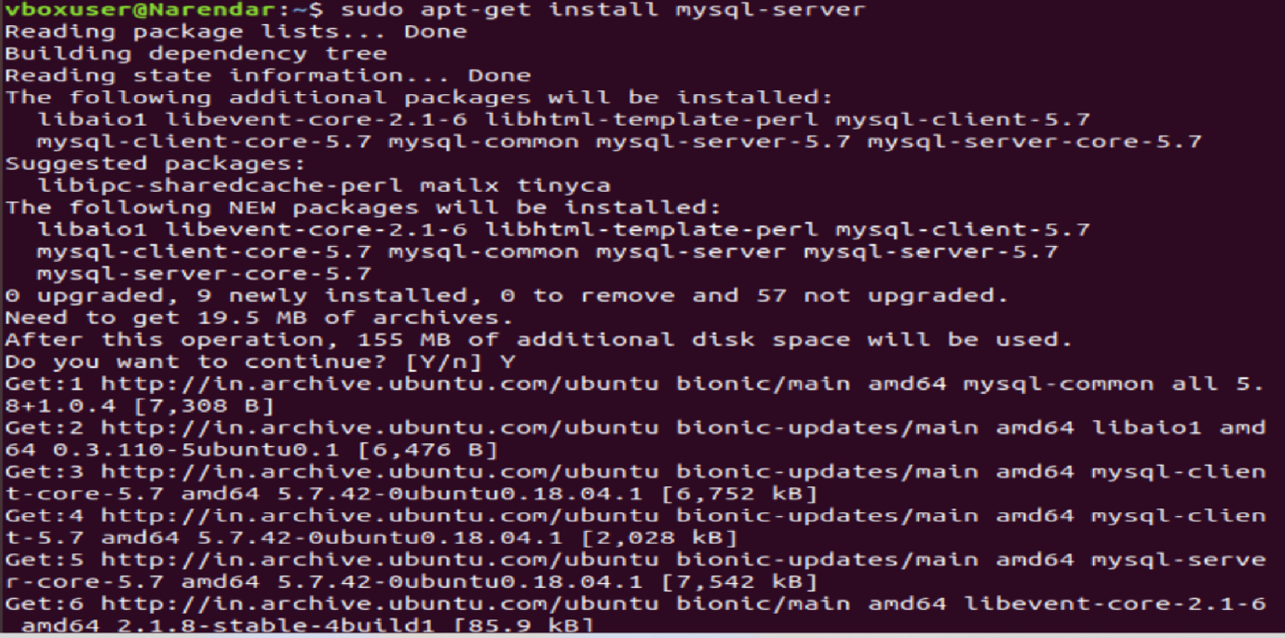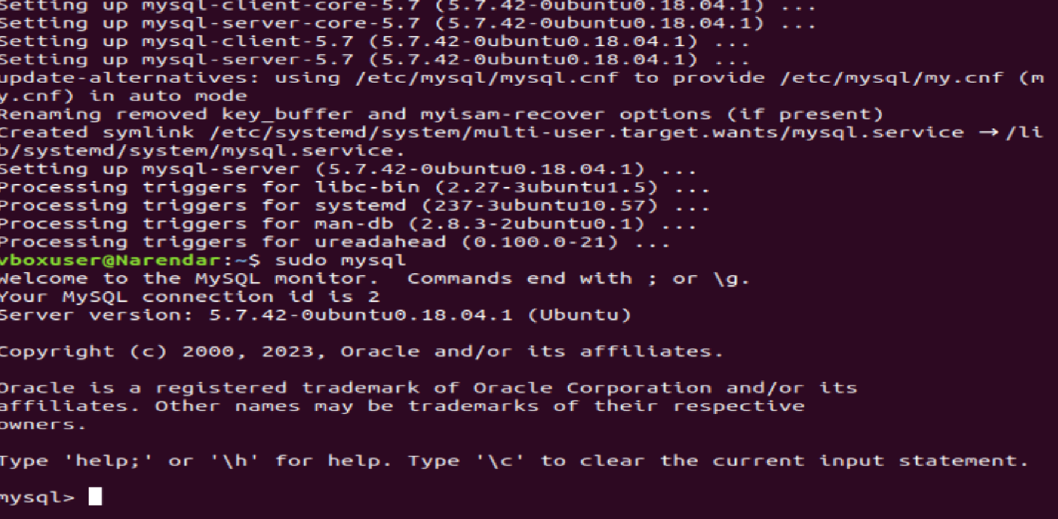

**28) Set up a Application Server (e.g.,Apache Tomcat)**

**29) create a service file for Apache Tomcat.(Should execute by using systemtctl command)**

**30) Print specific columns from a delimited file.** 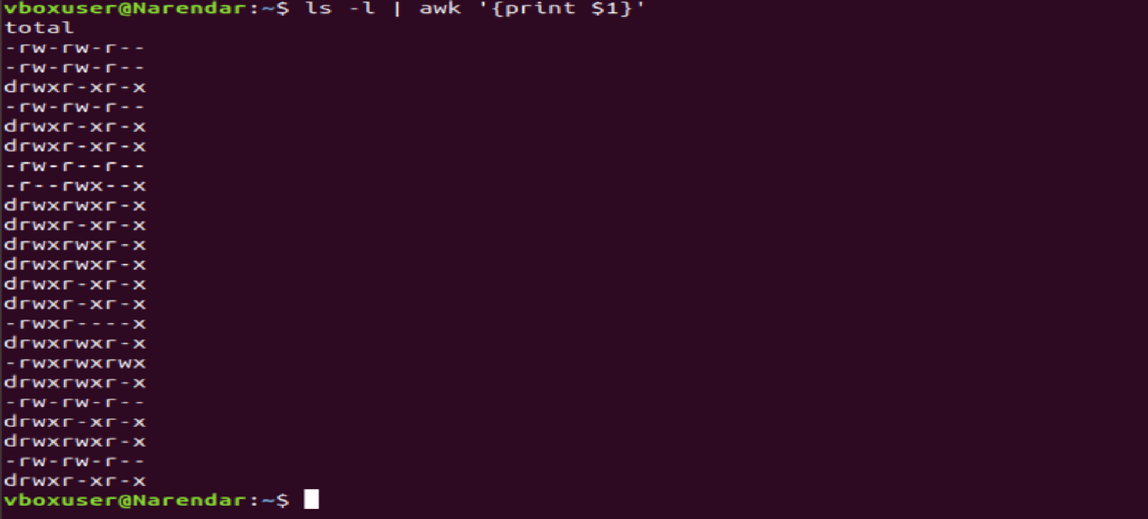

**31) Filter and print lines based on a specific pattern or condition.** 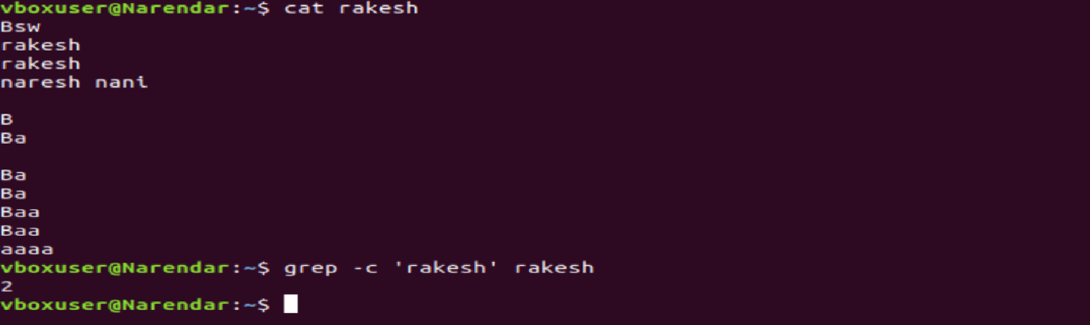

**32) Calculate and print the average, sum, or other statistics of a column**

**33) Perform string manipulation, such as extracting substrings or changing case.** 

**34) Count the occurrences of a specific pattern in a file**

**35) Sort lines based on a specific field or column.** 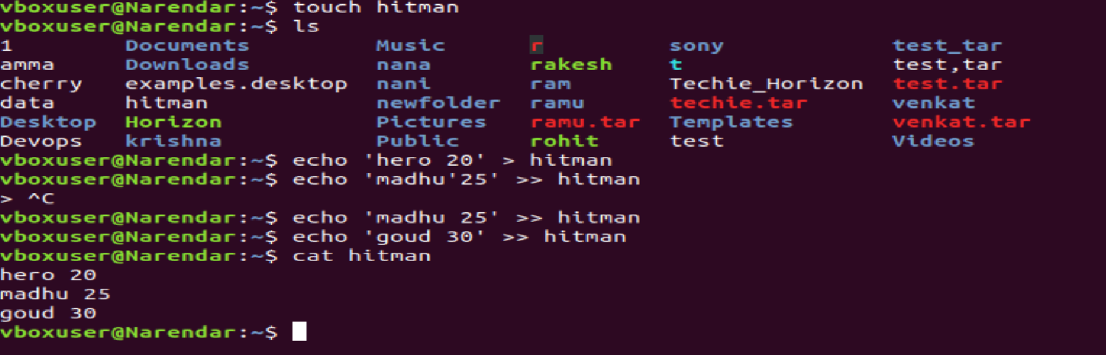

**36) Merge multiple files based on a common field or column** 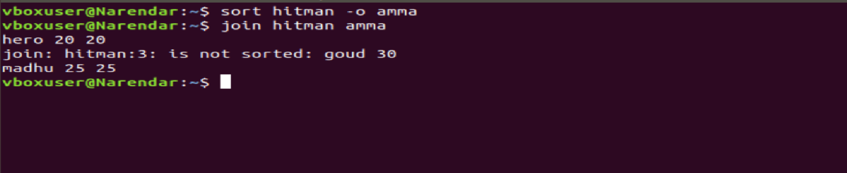

**37) Substitute text in a file using search and replace.** 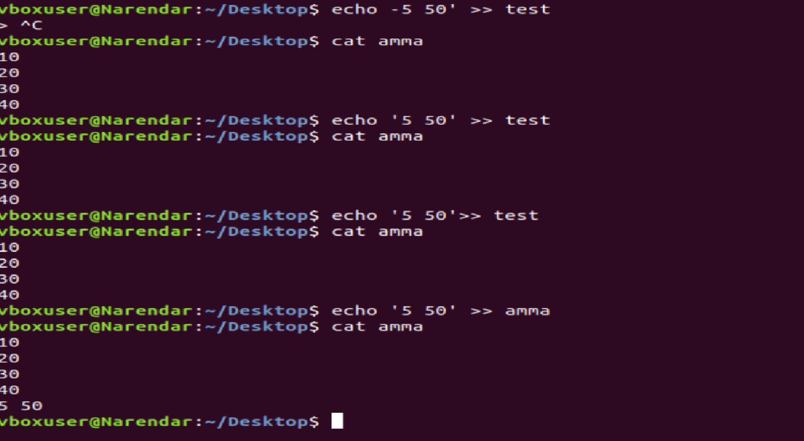

**38) Delete specific lines based on a pattern or line number** 

**39) Append or insert text before or after a specific pattern or line.** 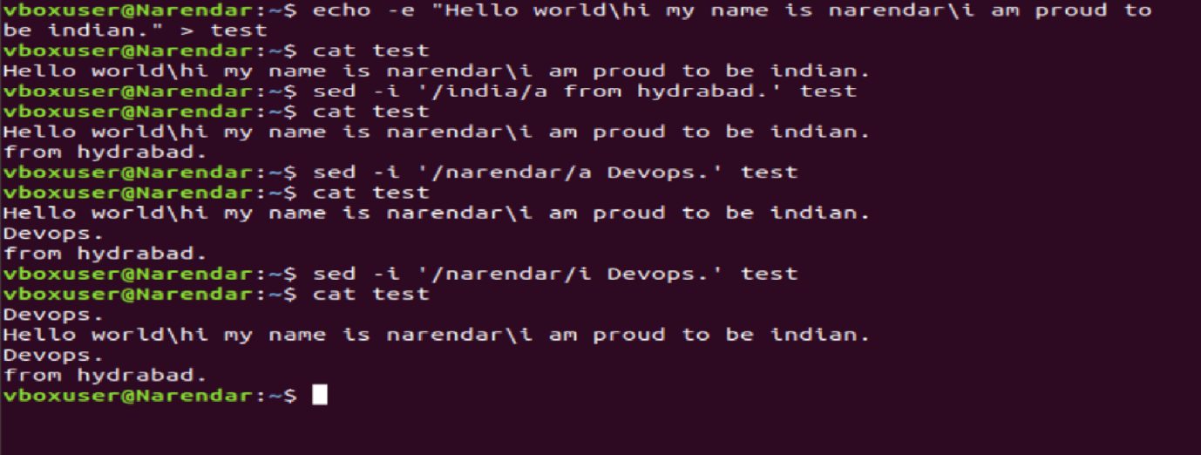

**40) Print only specific lines from a file** 